- A second successive rise in GDP in February and an upward revision to January's increase bolstered our confidence that the UK economy is finally beginning to recover after two years of stagnation. With timelier indicators for March also positive, GDP is on track to grow by 0.4% q/q in Q1, which would reverse the fall seen in H2 2023.
- Ben Bernanke's long-awaited report offered a scathing verdict on the Bank of England's forecasting model. He was similarly critical about the BoE's fan charts, recommending greater use of scenarios both as an input into Monetary Policy Committee discussions and as a communications tool. This is an approach we've been using for more than a decade.
We've been arguing for some time that 2024 would see the UK economy finally pull out of its two-year period of stagnation. Last month's GDP release for January had been an encouraging start to that process, and this week's release bolstered our conviction that the economy is finally on the road to recovery.
The Office for National Statistics upgraded its estimate of m/m GDP growth in January to 0.3%, from 0.2%, and a further gain of 0.1% in February consolidated the upturn. The rebound in activity in the early months of the year has mirrored the recent pickup in the composite PMI (Chart 1). Indeed, the recovery in GDP would have been stronger but for the impact of two factors not captured by the composite PMI. First, unusually wet weather disrupted activity in the construction sector in February, with output falling 1.9% m/m. Second, strikes by NHS workers meant that a large number of working days were lost around the turn of the year, causing sizeable damage to health output.
Early indications for March are positive. All three S&P Global surveys reported rising activity for the first time since September 2022. The number of working days lost to strikes in the health and transport sectors appears to have been very low. And the British Retail Consortium's Retail Sales Monitor echoed the recent CBI survey in suggesting that Easter being earlier than normal provided a fillip to retail demand. Absent historical revisions, GDP is on track to grow by around 0.4% q/q in Q1.
Chart 1: GDP has strengthened in early-2024, mirroring the improvement in the composite PMI
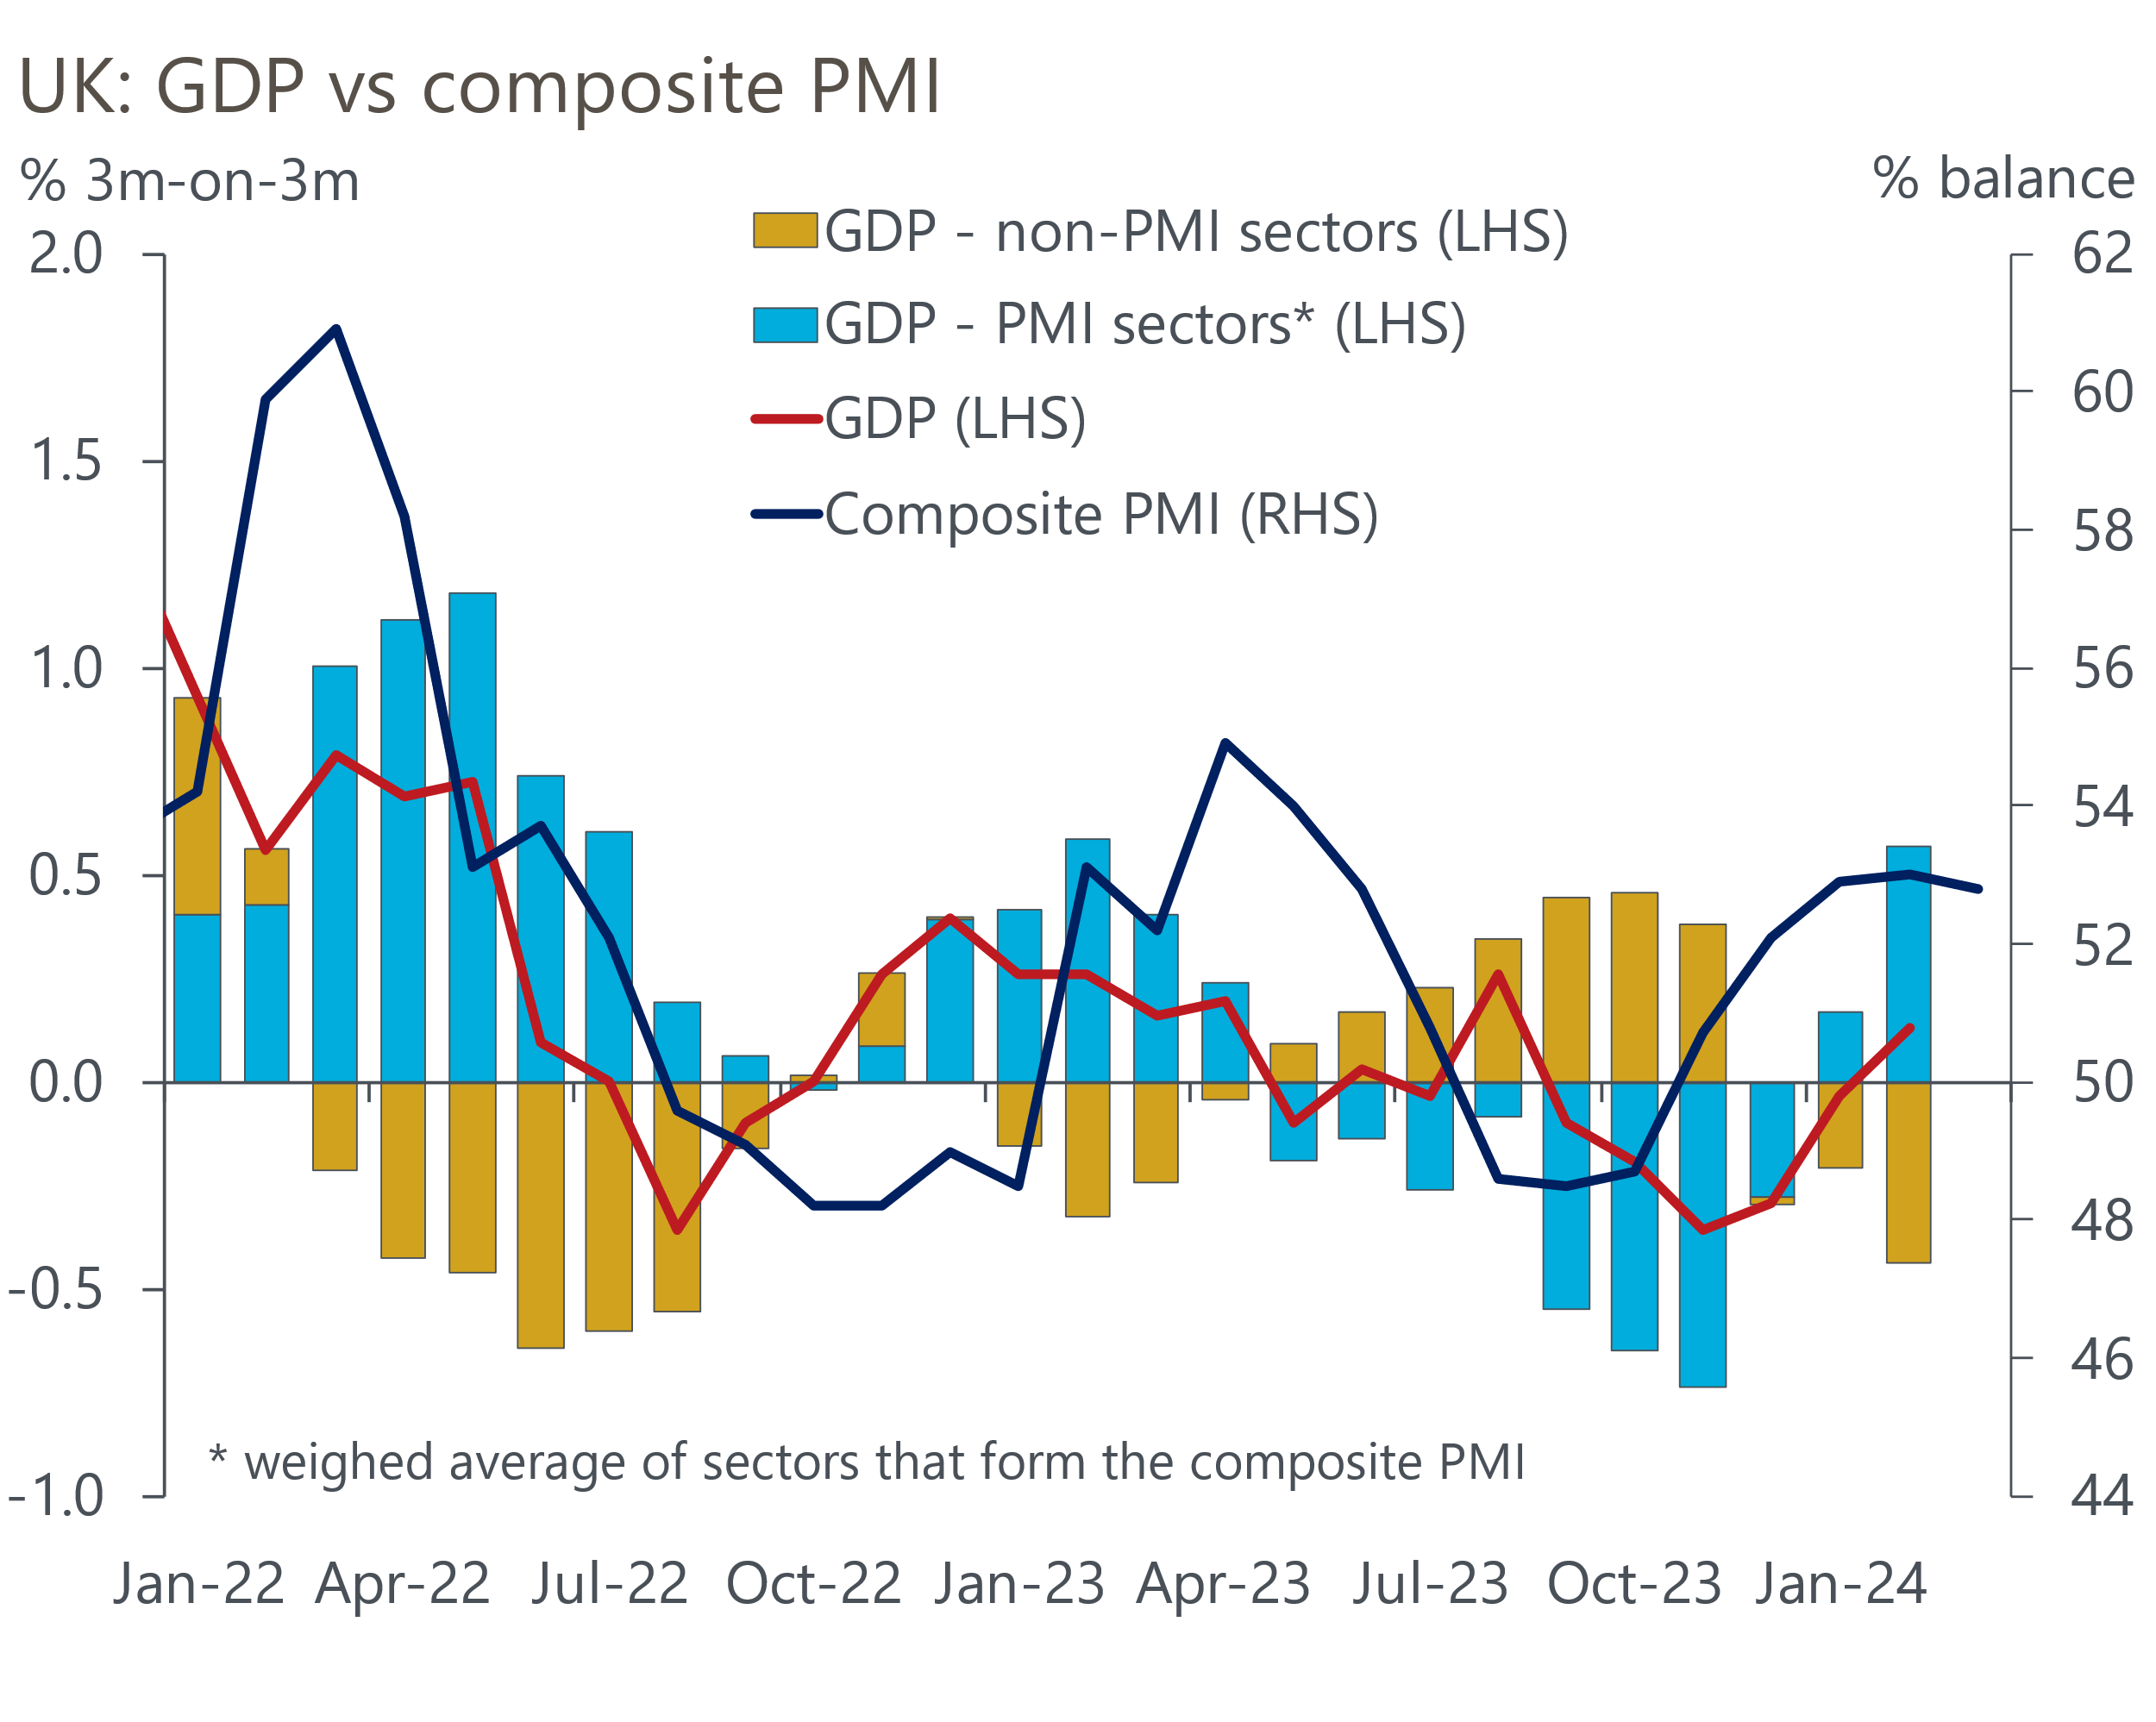
Sources: Oxford Economics/ONS/S&P Global

The mood of financial markets has turned more hawkish this week, with market pricing now implying just two 25bps rate cuts this year. At market close on Thursday, two- and five-year swap rates were up by around 25bps on a week earlier. Bank of England data suggests average fixed mortgage rates have already nudged up by 10-25bps between January and March (Chart 2). If sustained, the latest increase in swaps could put further upward pressure on mortgage rates and temper the more upbeat mood evident in residential markets in recent months.
Chart 2: Mortgage rates have nudged up in recent months in response to rising swap rates
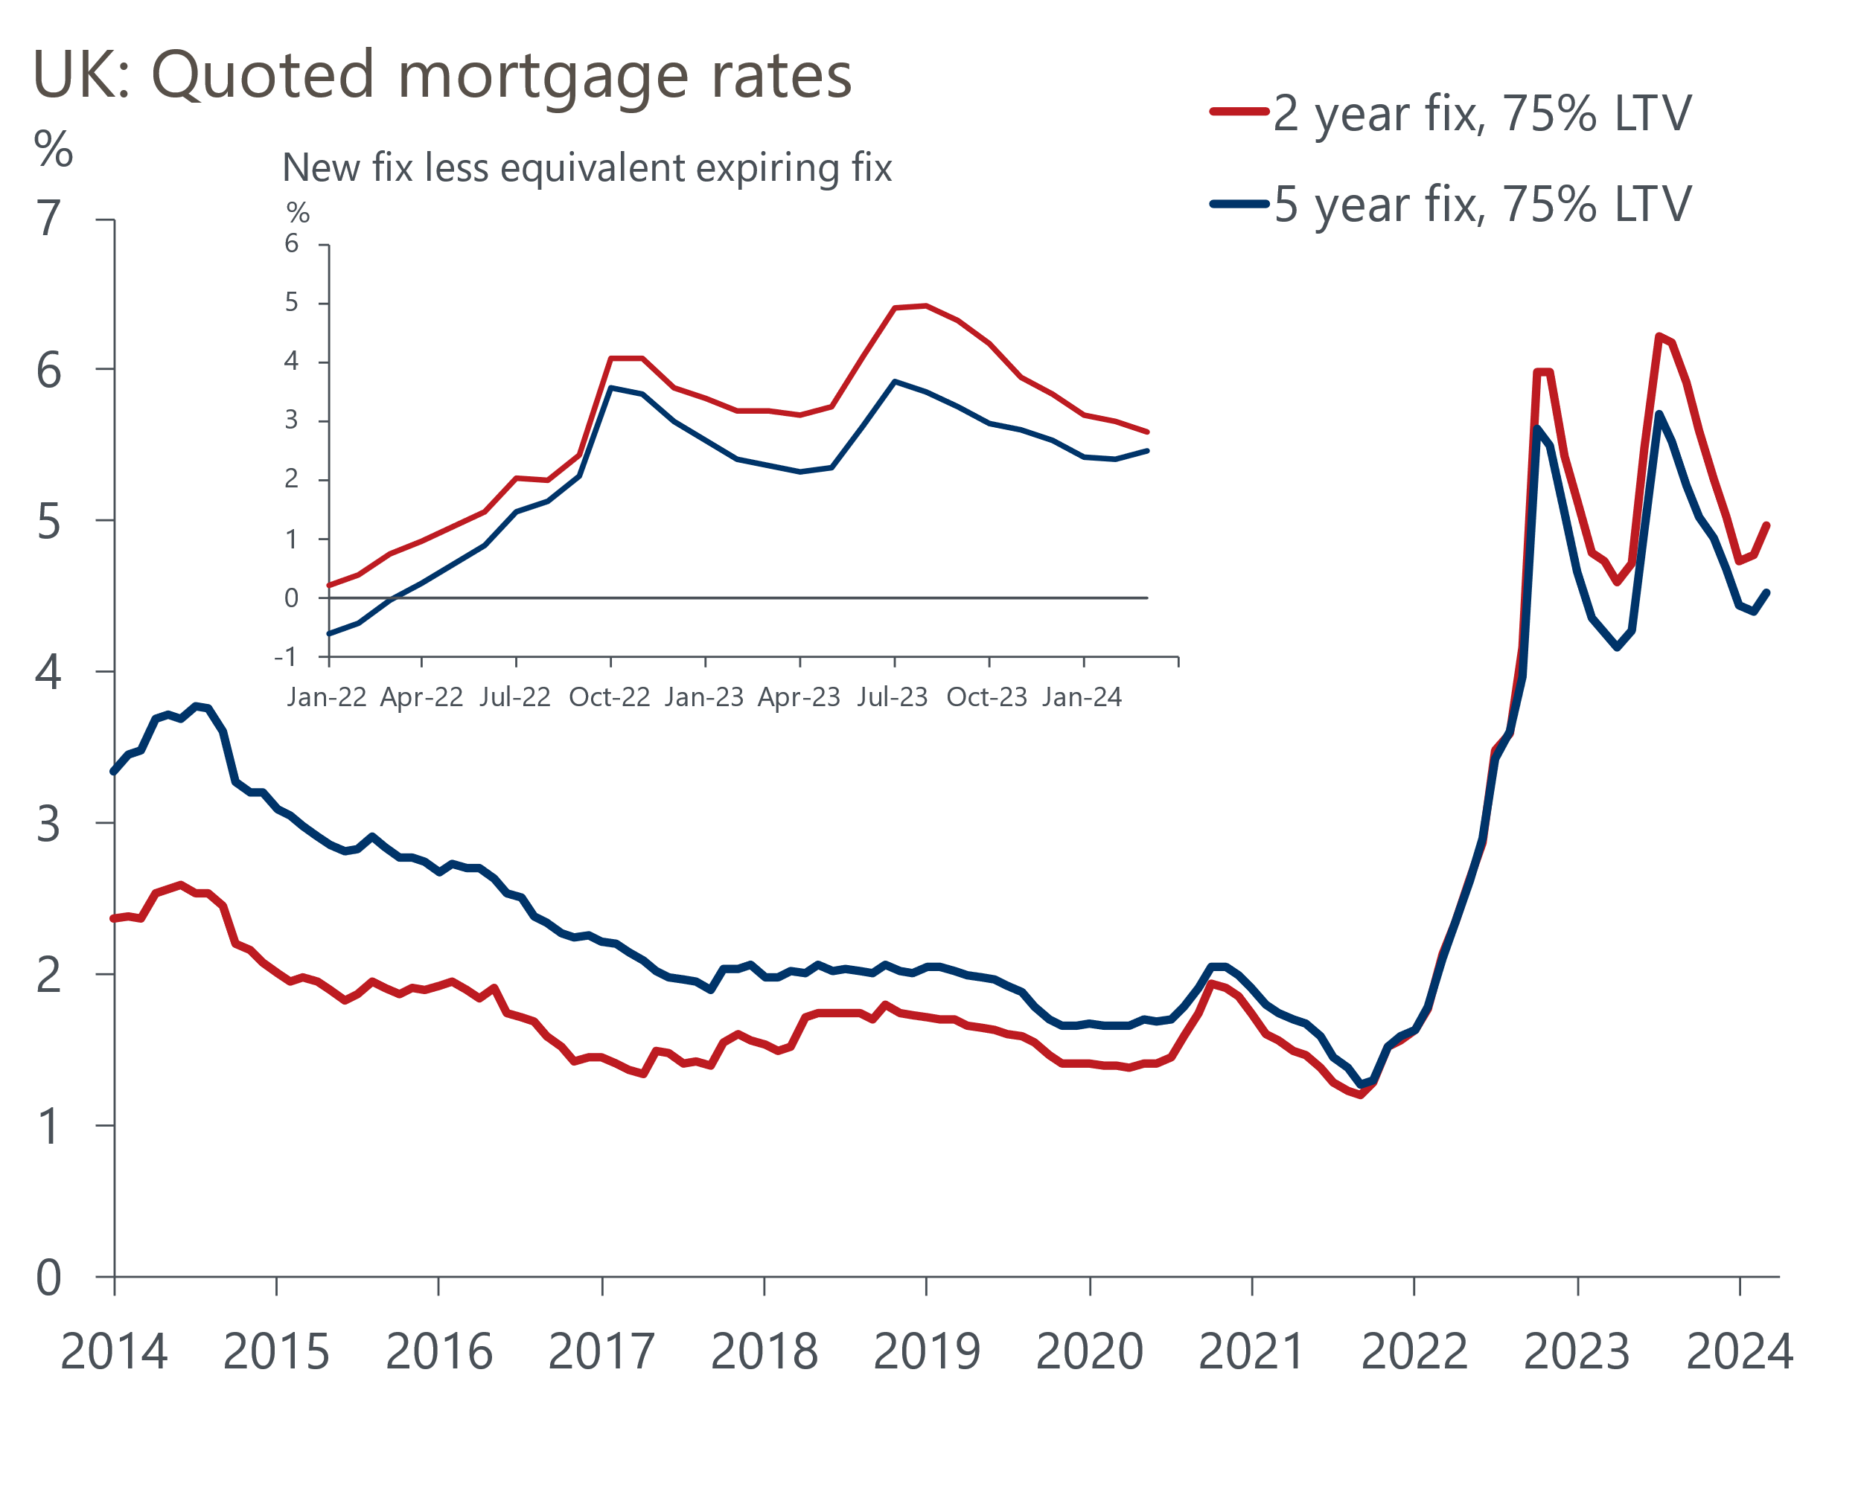
Source: Haver Analytics
But this week's market moves were triggered by events in the US, where CPI inflation came in higher than expected in March. The next day, the Financial Times published an op-ed from external Monetary Policy Committee member Megan Greene that argued markets should stop comparing the US and UK. We agree that there's no obvious read-across from the US inflation release to the UK. But where we differ from Greene is the suggestion that the risk of inflation persistence is much greater in the UK.
We don't think Greene's assertion that "rate cuts in the UK should still be a way off" is noteworthy in terms of the monetary policy outlook. The March minutes had talked of a wide range of views among those voting for no change, and we had placed Greene at the more hawkish end of the spectrum given she had voted for rate hikes until December. The five internal members remain key, and we still think there's a good chance that at least four will join Swati Dhingra in voting to cut rates in June.
Finally, this week saw the publication of the long-awaited review into the BoE's forecasting process, led by former Fed Governor Ben Bernanke. Dr Bernanke made 12 recommendations in three broad categories: improving the BoE's forecasting infrastructure; providing a process that better supports the MPC's decision-making; and helping present the MPC's views to the public.
The review was scathing in its verdict on the BoE's COMPASS model, which has fallen into such a state of disrepair that the BoE has stopped using it for key parts of the forecasting process. With only 18 variables (by contrast, just the UK section of our Global Economic Model has well over 1,000), it is also too simplistic and doesn't cover key parts of the economy or monetary transmission.
He was similarly critical of the BoE's trademark fan charts, which he said "appear to have little or no explicit grounding in data or quantitative analysis". Instead, he recommended the production of scenarios alongside the central projection. This is an approach that we adopted well over a decade ago through our Global Scenarios Service, so this move looks to be sensible, if hardly revolutionary. That said, such a switch will present communication challenges, an area the BoE has tended to struggle with in the past.
In its response, the BoE committed to addressing the recommendations but only promised to provide an update on the proposed changes by the end of the year. This fairly lukewarm response suggests there's unlikely to be any substantive changes this year.

The week ahead
There's little reason to think that next week's labour market data will change the previous story of a tight jobs market. Although the unemployment rate in the November-January period ticked up a little, at 3.9%, it was still very low by historical standards. Job vacancies continued to fall back but remained above pre-pandemic levels. Timelier evidence, such as the claimant count unemployment rate and survey evidence on recruitment difficulties, have pointed to a slightly rising profile for joblessness. But we don't think this will be enough to stop the unemployment rate sticking at 3.9% in the three months to February.
Pay growth has been on a downward trajectory since last summer and we expect that trend to have continued in early 2024. A fall in inflation expectations among workers and firms and a modest loosening in the jobs market point in that direction, although some evidence, such as the BoE's DMP survey, suggested a degree of stickiness at the start of this year. We expect total pay to have risen 5.5% in the three months to February, slightly down from 5.6% in the previous three-month period.
Meanwhile, we think March will have marked the first sub-3% reading for CPI inflation since July 2021. Base effects should have continued to push down the annual rate, particularly in the food and core categories. However, that petrol prices rose between February and March this year, versus a fall in the same period in 2023, will have put some offsetting upward pressure on inflation. Overall, we think the CPI measure fell to 2.9% in March from 3.4% the previous month.
Retail sales volumes have been very volatile of late, and the combination of another unusually wet month and an early Easter means there's a high chance of another unpredictable outcome in March. The CBI and BRC surveys suggest that the Easter effect is likely to dominate, boosting food sales in particular. So we forecast that retail sales rose by 0.4% m/m in March.
Table 1: Week ahead calendar
Date | Events | Period | Measure | Unit | Previous | Forecast
Apr 16 | LFS unemployment | Dec-Feb | Rate | % | 3.9 | 3.9
Apr 16 | Average earnings (total pay) | Feb | 3m, y/y | % | 5.6 | 5.5
Apr 16 | Average earnings (regular pay) | Feb | 3m, y/y | % | 6.1 | 5.8
Apr 17 | CPI inflation | Mar | m/m | % | 0.6 | 0.3
Apr 17 | CPI inflation | Mar | y/y | % | 3.4 | 2.9
Apr 17 | RPI inflation | Mar | m/m | % | 0.8 | 0.5
Apr 17 | RPI inflation | Mar | y/y | % | 4.5 | 4.3
Apr 17 | Producer input prices | Mar | m/m | % | -0.4 | -0.3
Apr 17 | Producer input prices | Mar | y/y | % | -2.7 | -3.2
Apr 17 | Producer output prices | Mar | m/m | % | 0.3 | 0.2
Apr 17 | Producer output prices | Mar | y/y | % | 0.4 | 0.6
Apr 17 | Land Registry house prices | Feb | y/y | % | -0.6 | -0.3
Apr 19 | Retail sales inc fuel | Mar | m/m | % | 0.0 | 0.4
Apr 19 | Retail sales inc fuel | Mar | y/y | % | -0.4 | 1.1
Source: Oxford Economics

Key forecasts
Table 2: UK forecast overview
(Annual percentage changes unless specified)
 | 2022 | 2023 | 2024 | 2025 | 2026 | 2027
GDP | 4.3 | 0.1 | 0.5 | 2.0 | 2.0 | 1.6
Private consumption | 4.8 | 0.2 | 0.9 | 2.6 | 2.2 | 1.6
Fixed investment | 8.0 | 2.2 | -2.8 | 1.1 | 2.8 | 2.1
Government consumption | 2.3 | 0.5 | 4.1 | 2.2 | 1.5 | 1.5
Exports of goods and services | 9.0 | -0.5 | -0.5 | 2.7 | 2.4 | 1.7
Imports of goods and services | 14.6 | -1.5 | 2.2 | 3.5 | 2.9 | 1.9
Industrial Production | -3.5 | -0.3 | 0.1 | 0.9 | 1.5 | 1.1
Consumer prices | 9.1 | 7.3 | 2.1 | 2.1 | 2.3 | 2.2
Unemployment rate (%) | 3.9 | 4.0 | 4.0 | 3.9 | 3.8 | 3.7
Current a/c balance (% of GDP) | -3.1 | -3.3 | -3.0 | -2.9 | -3.0 | -2.9
Government balance (% of GDP) | 4.4 | 5.0 | 3.5 | 3.0 | 2.2 | 1.5
Cen. bank policy rate (%, EOP) | 3.50 | 5.25 | 4.50 | 3.50 | 2.50 | 2.00
10yr govt. bond yield (%, EOP) | 3.67 | 3.54 | 3.85 | 3.51 | 3.05 | 2.85
Exchange rate (US$ per £, EOP) | 1.20 | 1.27 | 1.27 | 1.27 | 1.28 | 1.30
Exchange rate (euro per £, EOP) | 1.13 | 1.15 | 1.16 | 1.15 | 1.15 | 1.14
Source: Oxford Economics
Table 3: Quarterly forecasts for the UK
 | 2024 |  |  |  | 2025
 | Q1 | Q2 | Q3 | Q4 | Q1 | Q2 | Q3 | Q4
GDP (% year) | -0.1 | 0.2 | 0.7 | 1.5 | 1.7 | 2.0 | 2.1 | 2.2
CPI inflation (% year) | 3.4 | 1.7 | 1.6 | 1.8 | 1.9 | 1.9 | 2.3 | 2.3
Bank Rate (%, EOP) | 5.25 | 5.00 | 4.75 | 4.50 | 4.25 | 4.00 | 3.75 | 3.50
10yr gilt yield (%, EOP) | 3.95 | 3.95 | 3.91 | 3.85 | 3.78 | 3.70 | 3.61 | 3.51
US$ per £ (EOP) | 1.26 | 1.27 | 1.27 | 1.27 | 1.27 | 1.27 | 1.27 | 1.27
Euro per £ (EOP) | 1.17 | 1.16 | 1.16 | 1.16 | 1.16 | 1.16 | 1.15 | 1.15
Source: Oxford Economics

Latest Country Economic Forecast:
March 18, 2024

Recent publications

Data Insights
GDP rose in February and remains on course to rebound in Q1
Lower services PMI still points to healthy activity growth in Q1
Manufacturing output returned to growth in March
Recovery in mortgage demand continues
National accounts confirm the weak performance over H2 2023

Research Briefings
The MPC and rates - preparing to descend Table Mountain
MPC remains on track for a June rate cut
MPC preview – Caution is the name of the game
Rethinking the UK’s fiscal rules is a key to unlock growth
Is 'immaculate disinflation' likely?

Contacts

Oxford Economics' UK team
- Andrew Goodwin - Chief UK Economist - agoodwin@oxfordeconomics.com
- Edward Allenby - UK Economist - eallenby@oxfordeconomics.com

